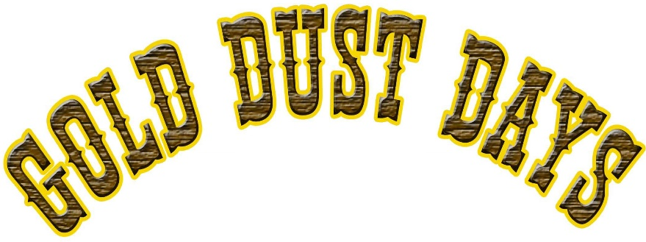

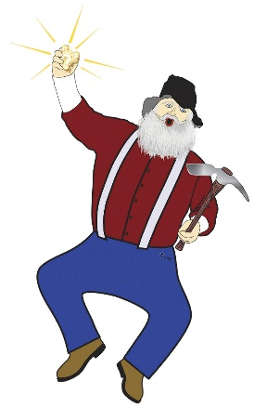
The 15th Annual Gold Dust Days Heritage Festival is on its way, and we're thrilled to announce that we've made some exciting additions to our activities. In addition to the car show and kid's activities, there will be a street fair featuring hand-crafters and artists. We've also included a new event, the Gold Rush! Miners Cart Race. The race involves home-built carts and teams maneuvering through an obstacle course while digging for gold.

If you're interested in sponsoring the festival and being part of this great community event, we have three sponsorship opportunities available to meet everyone’s budget:
- Nugget Level: $50.00
Your company name and contact information will be featured on our website, and your commercial vehicle will be included in the Saturday morning parade.
- Silver Level: $100.00
You'll receive the above benefits, plus your logo, a short blurb about your company on our website, and a shoutout at the Miners Cart Race.
- Gold Level: $200.00
You'll get all the above benefits, plus a longer blurb about your company on our website, your logo and company name on the Festival Poster (distributed from Everett to Wenatchee), and recognition on a banner at the event. You'll also receive Facebook/Instagram posts, a banner, and a shoutout at the Miners Cart Race.

Gold Bar, WA
July 27,2024

July 27,2024

SPONSORSHIP FORM

Business Name:
Contact Name:
Address:
Phone: Email:
Website:

I would like to be a sponsor:

Please make checks payable to the Sky Valley Chamber of Commerce and return this form to:

Sky Valley Chamber of Commerce
PO Box 46
Sultan, WA 98294

OR go to SkyValleyChamber.com to sign up and pay online!

Logo’s must be emailed in JPEG format to Debbie@skyvalleychamber.com
Thank you for sponsoring the 15th Annual Gold Dust Days!

Questions? Contact Debbie Copple Or Melody Dazey at 360-793-0983 or Debbie@skyvalleyvic.net or Melody.dazey@SkyValleyvic.net

